Mind Mapping – Template
1. Define the central idea or problem to be represented the centre of the map.
Click or tap here to enter text.

2. From the central idea or problem, record all ideas or solutions that come to mind, linking them with a line.

3. Determine which of the branched ideas from the previous step are of greatest importance and generate sub-branches from these branches. The mind map should be in a form like that pictured below.
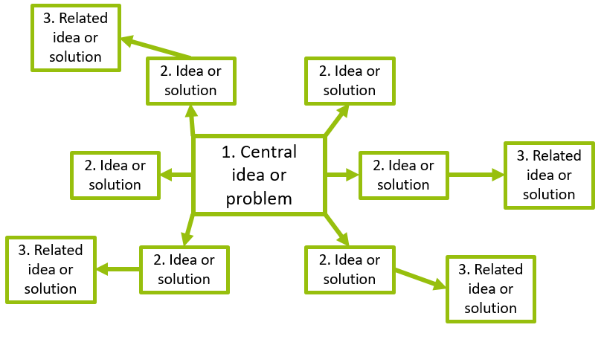

4. Take a break to reinvigorate thought processes.

5. Upon returning to the task, create a new map where the topics identified in steps 2 and 3 are rearranged and new associations and hierarchies are identified. Examine any reoccurring ideas in greater detail.

6. Synthesise the information and structure from the two mind maps to form a comprehensive, composite mind map.

7. Examine the composite mind map and the connections between branches. Add any branches or modify connections, if required. Take frequent breaks to maintain clarity of thought, utilise colour coding, and ensure branch descriptions are short.

