Vroom-Yetton-Jago Decision Model – Template
1. Answer the questions and follow the arrows appropriate to your response on the decision tree depicted below.
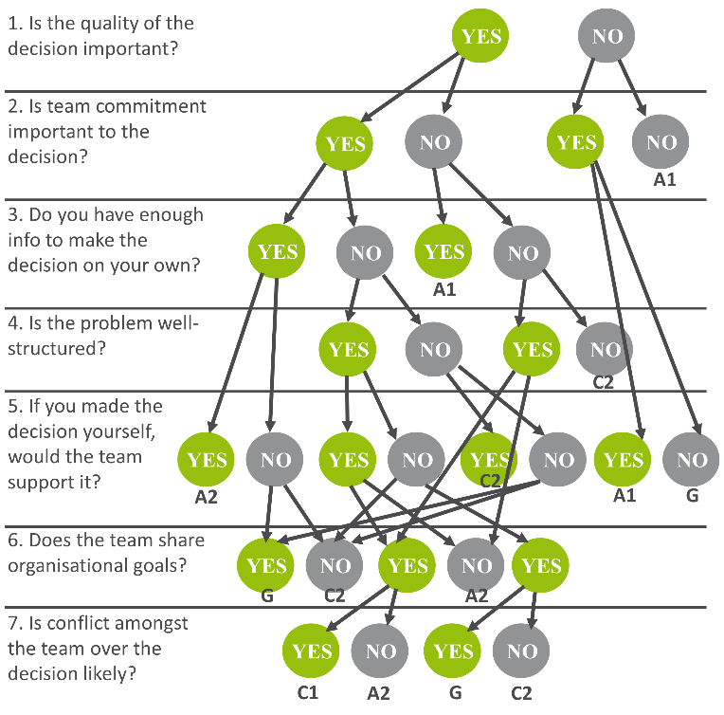

2. Match the code obtained through the decision tree with its corresponding option below. Utilise this decision-making process.
Code | Process name | Description
(A1) | Autocratic 1 | The leader uses the information that they already have to make the decision themselves.
(A2) | Autocratic 2 | The leader asks team members for specific pieces of information, but may not inform the team about the decision to be made.
(C1) | Consultative 1 | The leader informs the team about the decision to be made, but will make the decision in isolation.
(C2) | Consultative 2 | The leader is responsible for the decision, but the team discuss the situation together.
(G) | Group | The team make the decision together. The leader’s role is as a facilitator and to support the team during this process.

